Deye-NTU Plan for RWA and Tokenization
This version: Jan 20, 2026

1. Introduction
In the transition to sustainable energy, Deye, the leading provider of photovoltaic (PV) inverters and energy storage solutions, aims to enhance its current AI-based electric system and incorporate a decentralized green energy asset framework. This “top-down” vision starts from Deye’s practical needs: leveraging artificial intelligence to optimize energy management while utilizing blockchain technology to decentralize and tokenize green energy assets. By integrating an AI-driven energy management system with a blockchain-based real-world asset (RWA) platform, Deye seeks to maximize renewable energy utilization, improve profitability for prosumers, and enable broader participation in clean energy markets.
To achieve this goal, we outline the current stage of Deye’s AI system (the Deye Copilot), describe the overall structure of a decentralized green energy asset system (the RWA system), and identify key challenges in both domains. Finally, we propose targeted research directions (work packages) to address these challenges, ensuring an effective synergy between advanced energy management and blockchain-based asset networks. This structured approach flows from high-level needs to specific research questions, providing a comprehensive roadmap for innovation.

1.1. Current Stage of Deye Copilot: Progress and Challenges
Deye has developed the “Deye Copilot”, an intelligent Energy Management System (EMS) that serves as an AI “co-pilot” for its inverters. Launched initially in Australia and now deployed across numerous global markets, Deye Copilot combines a core AI algorithm (“Energy Saver”) with a cloud-based Virtual Power Plant (VPP) network [1]. This system optimizes battery charging and discharging based on real-time electricity prices, weather forecasts, load demand predictions, and battery health data [2]. By dynamically performing “charge at low price + discharge at high price” operations, it secures stable gains through peak-valley arbitrage for individual solar-plus-storage installations

[1] R. Sengupta, “Deye Launches AI-powered ‘Deye Copilot’ For Australia,” TaiyangNews - All About Solar Power. Accessed: Jan. 28, 2026. [Online]. Available: https://taiyangnews.info/technology/deye-technologies-copilot-ai-virtual-assistant-australia
[2] pv magazine, “‘Deye Copilot’: AI-Driven ‘Energy Saver’ Builds a Multi-Layered Revenue Model for Energy Storage,” pv magazine International. Accessed: Jan. 28, 2026. [Online]. Available: https://www.pv-magazine.com/press-releases/deye-copilot-ai-driven-energy-saver-builds-a-multi-layered-revenue-model-for-energy-storage/

Deye’s energy-RWA initiative sits at the intersection of two mature domains, distributed energy deployment and modern blockchain infrastructure, so the question is no longer whether the system can be implemented, but whether it can be implemented in a way that is financeable, scalable, and defensible over a multi-year horizon. In practice, the main obstacles to an investable RWA business line are not “engineering completion,” but the higher-order frictions that determine whether sophisticated capital will participate and whether the product can operate reliably under scrutiny: credibility of real-world data, robustness of cashflow risk assessment, and stability of pricing and liquidity under compliance constraints. These frictions are precisely where a joint lab can create durable value—by converting operational uncertainty into measurable, auditable, and optimizable rules—thereby lowering the cost of capital, reducing dispute and monitoring costs, and increasing the repeatability of deployment across sites and jurisdictions.
The role of the university in this collaboration is therefore to supply research-grade methods and evaluation standardsthat industry delivery teams typically do not produce as part of implementation: formal metrics for data trustworthiness and auditability; principled frameworks for downside-risk pricing and stress testing; and compliance-aware market-design tools that quantify liquidity loss and discount/premium behavior before public trading is enabled. These outputs are not academic add-ons; they are the decision infrastructure that enables Deye to (i) present a credible financing narrative to institutional partners, regulators, and auditors, (ii) harden the system against adverse scenarios and disputes, and (iii) standardize the product into a repeatable, scalable RWA “template” rather than a one-off pilot. The three research directions in this report—(1) Trust and audit for energy-RWA data, (2) Cashflow structuring and risk pricing, and (3) Liquidity and price discovery in a restricted (compliant) market—are chosen to directly strengthen the core performance of the token system and to de-risk the transition from a restricted pilot phase to a broader market phase.
This report firstly outlines the design for Deye’s RWA tokens and reward distribution: issuing asset-backed tokens, verifying production data through an oracle pipeline, and distributing rewards on-chain. It then proposes a token-economics layer that converts the RWA cashflows into a standardized, liquid instrument via a vault and an AMM market, enabling scalable trading and broader investor access. Thirdly, several research directions of both academic value and potential for enhancing Deye's token system performance. Finally, the corresponding research timeline is proposed.
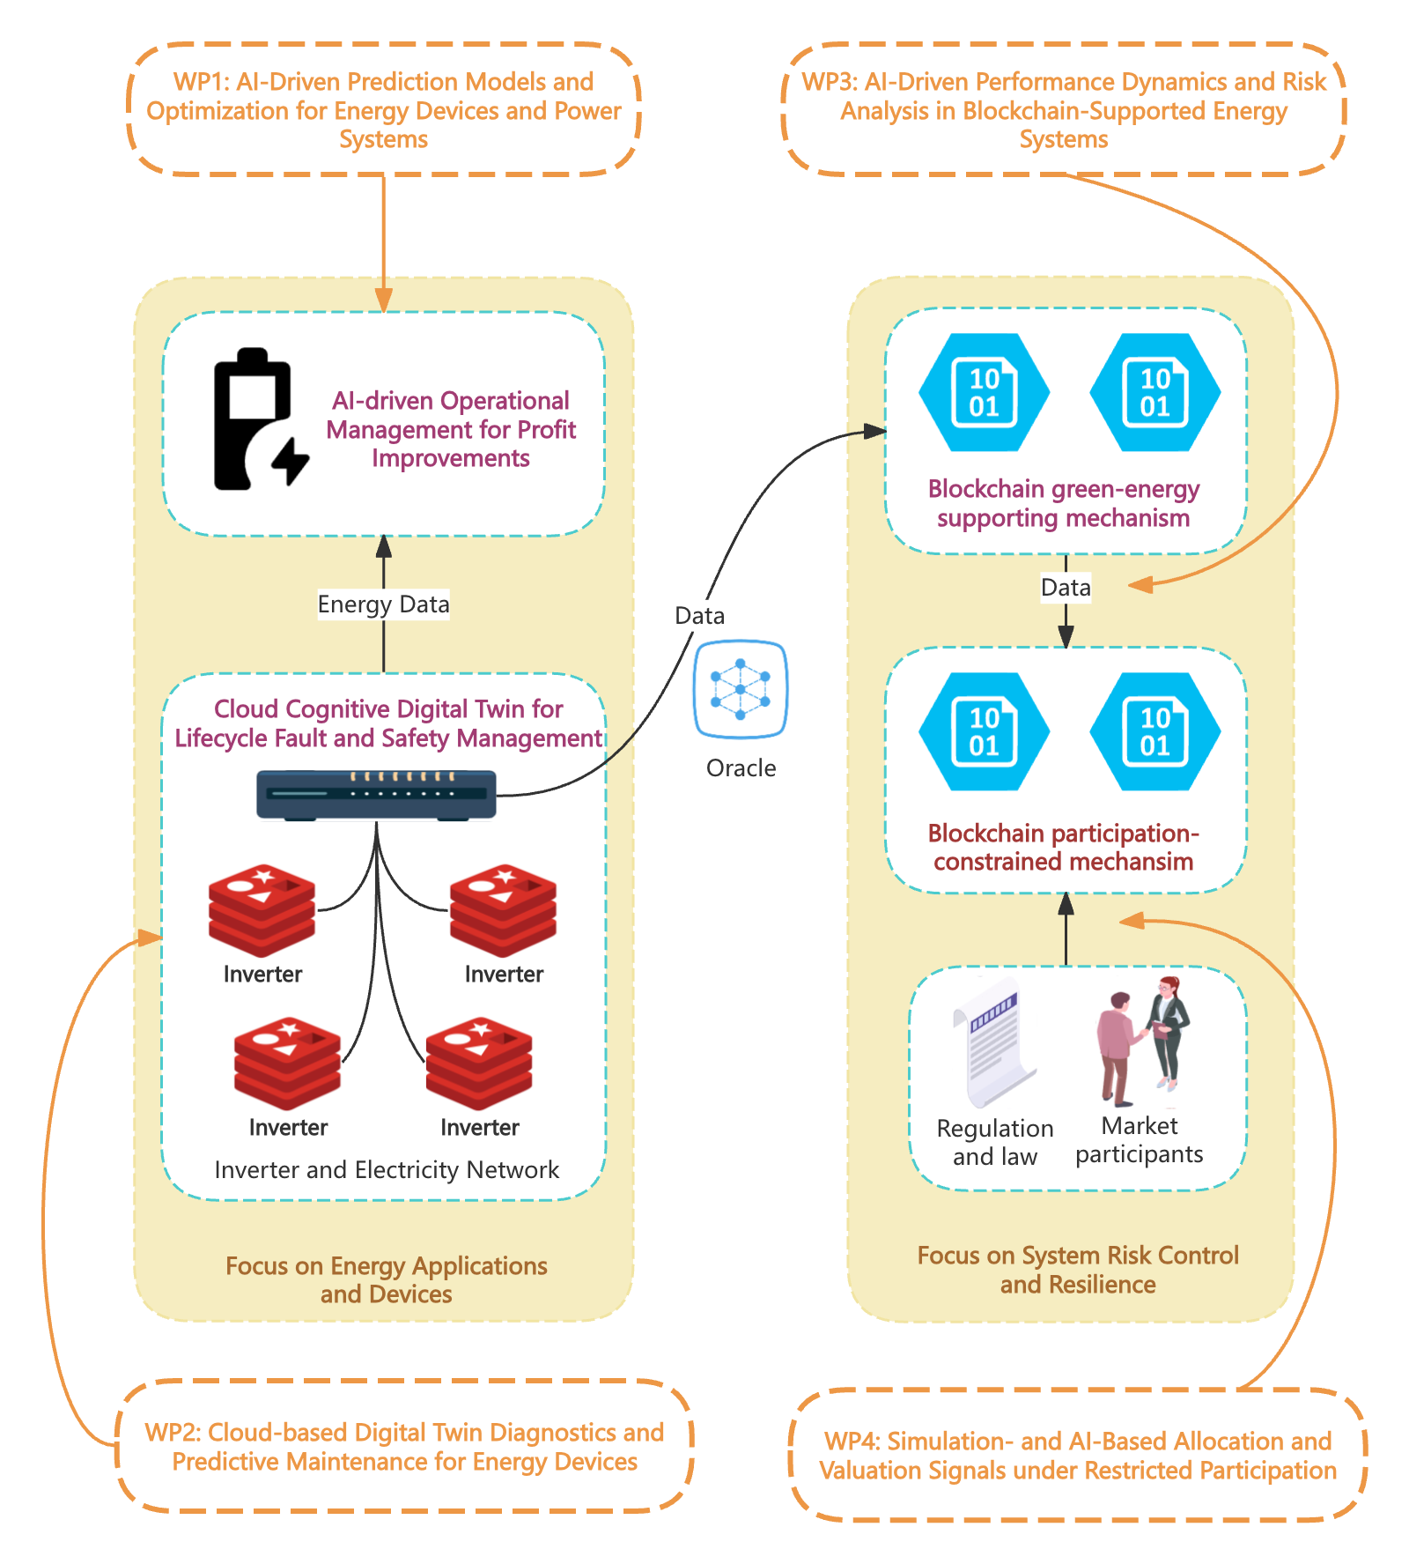

1. Workflow of RWA Token Issuance and Reward Distribution
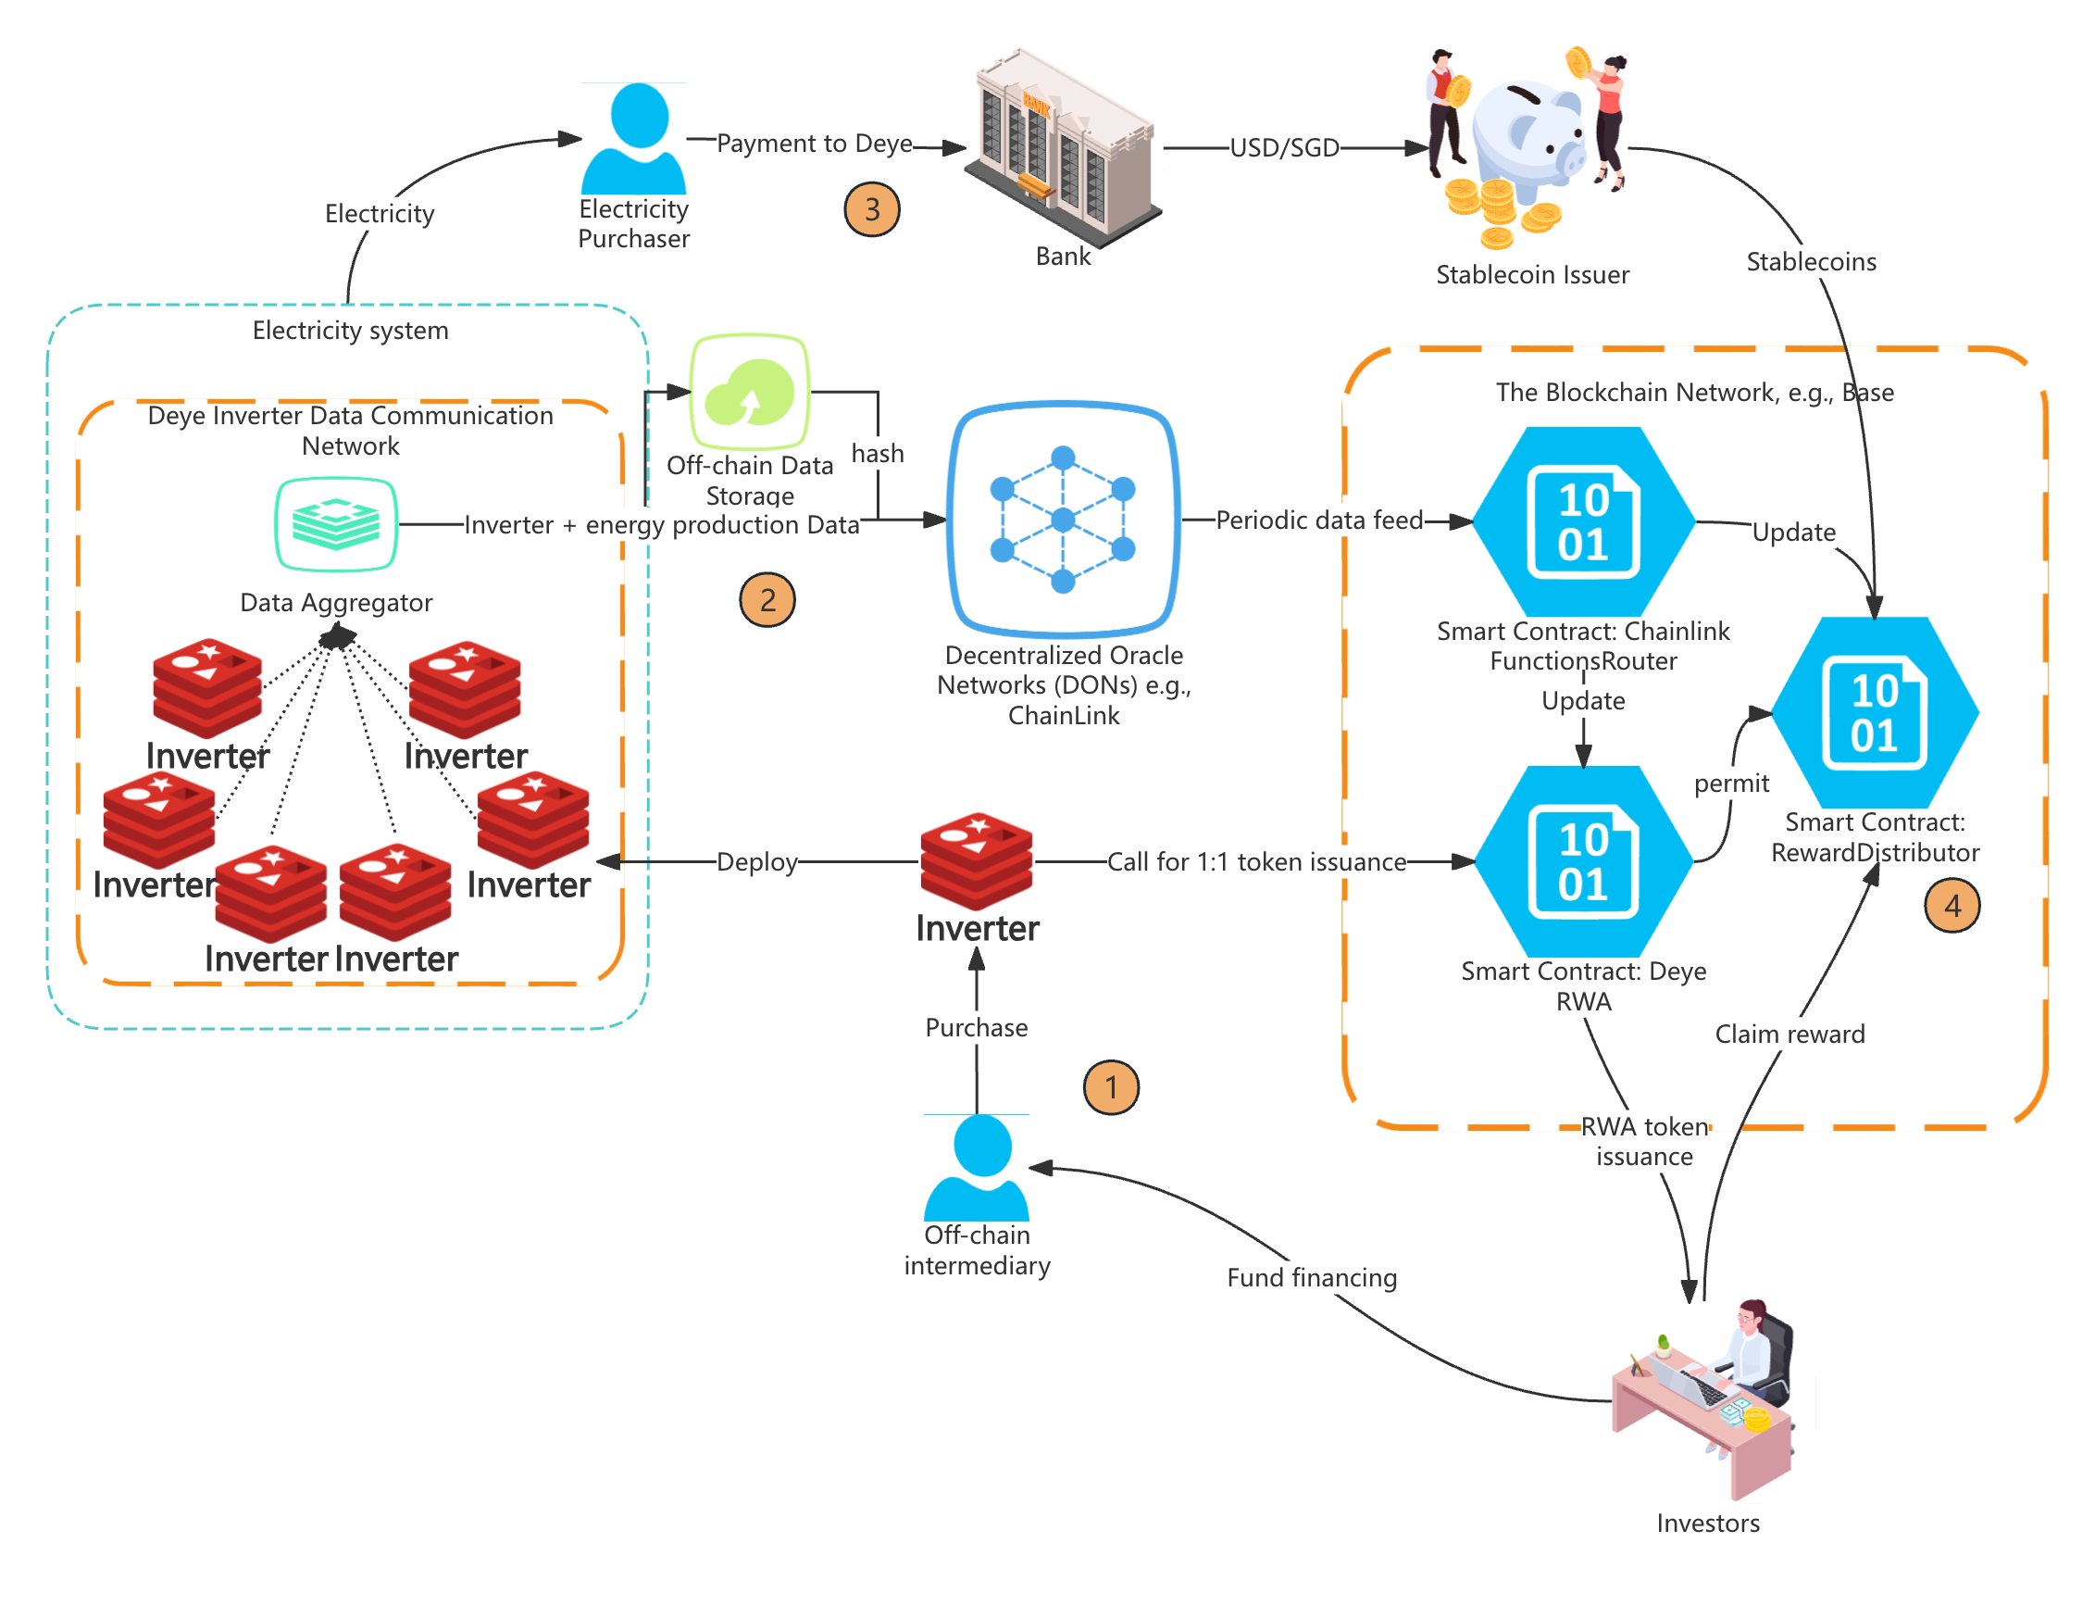
Figure 1 Workflow of Deye inverter RWA token issuance and reward distribution
Step ① inverter deployment and financing via RWA issuance. In this step, Deye finances the procurement and installation of a distributed fleet of rooftop inverters by issuing RWA tokens on an L2 chain (e.g., Base). The financing design must ensure that token issuance is not a standalone minting event, but a controlled workflow in which (a) each issued token is verifiably linked to a specific physical inverter (or an enforceable security interest in that inverter), (b) token transfers remain compatible with compliance requirements (e.g., KYC-gated circulation and emergency controls), and (c) only “activated” tokens—corresponding to commissioned, verified deployments—are eligible for subsequent periodically USDC reward distribution. Accordingly, the on-chain architecture should be implemented as two auditable contracts: a DeyeRWA contract that issues and manages inverter-backed tokens and their lifecycle states (mint/bind/activate/retire) and a RewardDistributor contract that custody-holds USDC and executes scalable, non-iterative reward claims, with each period’s distribution opening only after the corresponding USDC funding has been irrevocably transferred on-chain. The tokens are issued 1:1 for each inverter deployed.
Step ② Inverter data communication and oracle attestation (information stream for rewards). After deployment, Deye operates the inverter fleet within a dedicated data communication network that continuously records device-level production and status signals and transforms them into an auditable, on-chain-consumable “reward information stream.” The objective of this step is to (a) collect inverter telemetry at scale across many rooftops, (b) aggregate and normalize it into daily (or periodic) production records suitable for reward computation, (c) anchor the raw/processed dataset in off-chain storage with immutable hashes, and (d) deliver a consensus-attested output to the blockchain via a decentralized oracle network (DON) (e.g., Chainlink) and its router contract (FunctionsRouter smart contract). This step deliberately concerns information integrity rather than cashflow movement: it ensures that when Step ③ later transfers USDC to token holders, the payout amounts are traceable to verifiable energy production data, with clear provenance (device → aggregator → off-chain commitment → DON consensus → on-chain router callback).
Step ③ Cashflow settlement and on-chain reward funding (cashflow stream for rewards, parallel to Step ②). In parallel to Step ②’s on-chain recording of production and reward information, Step ③ governs the real-world cashflow lifecycle from electricity sales to on-chain USDC funding. The objective is to (a) realize monetization of generated electricity through contractual sale arrangements, (b) convert the resulting fiat proceeds into stablecoins and deliver them on-chain to the RewardDistributor contract, and (c) enforce consistency between “what was produced and recorded” (Step ②) and “what is paid out” (Step ③) through explicit reconciliation rules, audit trails, and on-chain solvency constraints. This separation—information stream vs. money stream—ensures that reward eligibility is determined by verifiable telemetry commitments, while payout execution is constrained by actually received and escrowed stablecoins.
Step ④ On-chain accounting update and investor reward claiming (execution layer). At this stage, both (a) the oracle-attested reward information from Step ② and (b) the funded stablecoin cashflow from Step ③ are available on-chain. Step ④ specifies how DeyeRWA (the ERC-3525 main contract) and RewardDistributor (the USDC vault/claim contract) are updated in a synchronized manner and how investors claim rewards. The recommended implementation is a Merkle-entitlement distribution model: for each day/period, the oracle pipeline produces (i) a production commitment (batch hash / Merkle root over inverter records) for auditability and (ii) a payout entitlement Merkle root over (claimerAddress, amount) for scalable claiming. This approach is preferred because it avoids on-chain holder enumeration and avoids relying on balance snapshots of an ERC-3525 token across many tokenIds; it scales cleanly to mixed investors and frequent distributions while preserving verifiability through cryptographic commitments anchored on-chain.

2. Token Economics and Liquidity Enhancing
The issuance-stage RWA design prioritizes asset precision and verifiability: under the preferred ERC-3525 standard, each token is bound to an individual inverter and thus carries device-specific attributes. While this strengthens traceability and compliance, it also introduces heterogeneity at the token level, which is difficult for the general public to interpret and price. Retail investors typically cannot evaluate hundreds of inverter-level risk–return profiles, verify device-level evidence, or manage individualized reward accounting. As a result, the native ERC-3525 layer is well suited for institutional financing and custody-grade asset representation, but it is not, by itself, an efficient market interface for broad participation.
This gap can be addressed by an explicit token-economics and DeFi-integrated layer that transforms heterogeneous, device-level cashflows into a standardized, fungible economic exposure. Rather than forcing the market to price thousands of distinct tokenIds, a vault pools the underlying ERC-3525 RWAs, internalizes the reward stream at the portfolio level, and issues a single ERC-20 receipt token whose value appreciates with the vault’s NAV. By listing this receipt token in an AMM pool against USDC, the design provides continuous liquidity and straightforward price discovery, making the product both tradable for institutions and accessible for retail investors through familiar DeFi primitives.
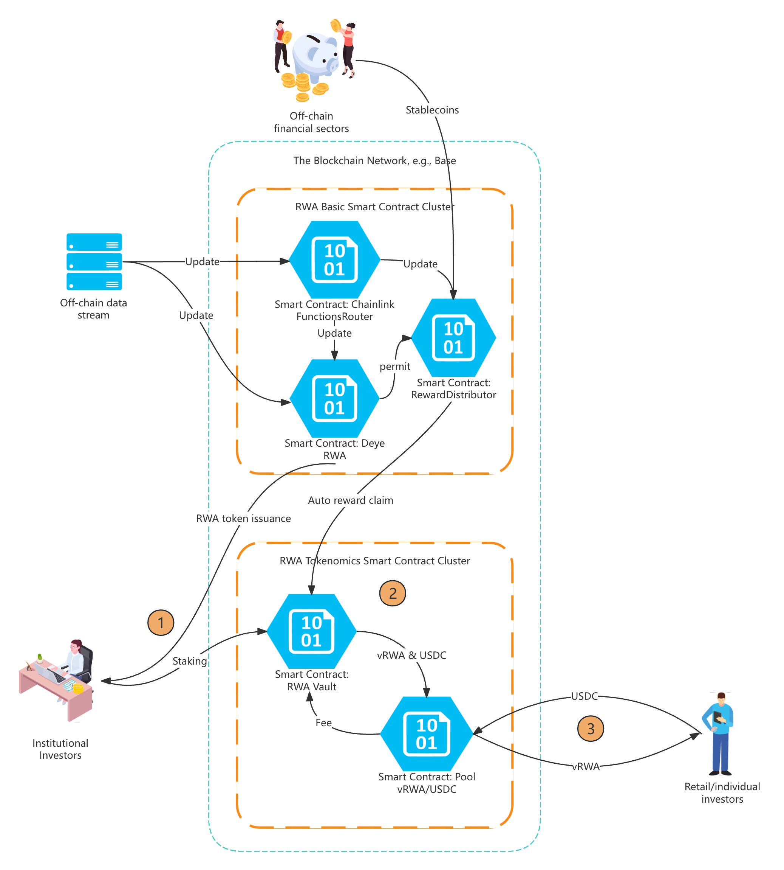
Figure 2 Deye RWA token economics design and circulation
Step ① Institutional staking into the RWA Vault and liquidity seeding of the vRWA/USDC pool. In this step, Deye introduces a secondary “tokenomics layer” on top of the native inverter-backed RWA token by (a) allowing institutional investors who hold the issued RWA token (ERC-3525) to stake those positions into an on-chain RWA Vault, and (b) minting an ERC-20 receipt/share token (vRWA) that represents a pro-rata claim on the Vault’s assets and accumulated rewards. The Vault is designed so that periodically USDC rewards, which would otherwise be claimed directly by native RWA holders, are instead claimed by the Vault and retained within it; consequently, the economic value of vRWA is intended to increase over time (via NAV/share appreciation) rather than requiring retail users to actively claim rewards. To provide continuous secondary-market access for smaller investors, a vRWA/USDC AMM pool is created, seeded with initial liquidity (protocol-owned or institution-provided), enabling retail buy/sell of vRWA using USDC while the underlying native RWA remains held and managed by the Vault. Economically, the pool enables price discovery of vRWA, but the intended “fundamental anchor” remains the Vault’s NAV per share. When vRWA trades below NAV (discount), economically rational actors may buy vRWA and redeem against the Vault (if redemption is available), pushing price back toward NAV; when vRWA trades above NAV (premium), institutions or the protocol can mint vRWA by depositing additional underlying RWA into the Vault and sell into the pool, increasing supply and compressing the premium.
Step ② and ③ Token-economics operation and market-making (vault accrual, arbitrage anchoring, and retail trading). After institutional RWAs are staked, the RWA Vault becomes the on-chain “economic transformer” that (i) continuously captures the inverter-generated USDC rewards and internalizes them into vault NAV (so vRWA appreciates), and (ii) interacts—directly or indirectly through arbitrage—with the vRWA/USDC AMM pool to keep the market price of vRWA disciplined around its fundamental value. Retail users then access exposure by trading vRWA in the AMM pool; the trading activity generates fees, which can be routed back to the vault (increasing NAV) or distributed as an additional incentive to long-term stakers, thereby creating a self-reinforcing liquidity loop.

3. Potential Research Directions

3.1. Trust and Audit for Energy-RWA Data
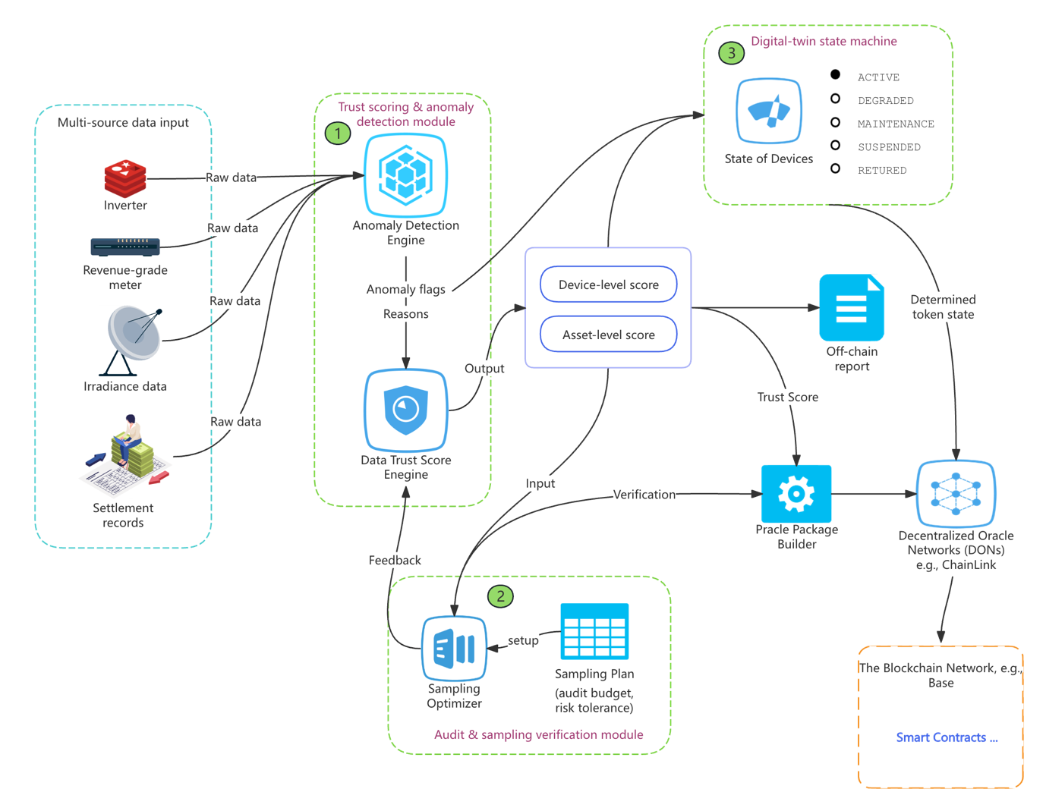
In an inverter-backed energy RWA system, the credibility of the token ultimately depends on the credibility of the underlying production and settlement data used to compute cashflows. This requirement is operationally demanding in distributed rooftop deployments: telemetry can be noisy or missing due to connectivity outages, devices may experience sensor drift or resets, and inconsistencies can arise across data sources (inverter readings, revenue-grade meters, irradiance signals, and settlement records). Because rewards are computed mechanically from these inputs, even moderate data quality issues can translate into payout errors, elevated dispute rates, and substantial manual verification and audit costs. The research objective in this track is therefore to provide systematic, explainable, and cost-efficient methods to quantify data trustworthiness, allocate verification effort, and formalize how device events and data confidence should translate into token states and payout rules. As illustrated in Figure 3, the proposed work is implemented as a trust-and-audit layer positioned between telemetry aggregation and the downstream oracle publication/reward computation pipeline; it produces standardized “oracle-ready” outputs together with cryptographic commitments and audit artifacts, strengthening the integrity and scalability of Deye’s RWA architecture. Three research directions can be proposed:
Figure 3 Research Direction: Trust and Audit for Energy-RWA Data
- ① Trust scoring and anomaly detection (device-level to asset-level). How should multi-source consistency checks and anomaly detection be designed to identify missingness, manipulation, and sensor faults, and then aggregate these diagnostics into interpretable trust scores at both the device level and the portfolio level? The intended output is an “Asset Data Trust Score” framework with explainable drivers, suitable for inclusion in the oracle package via hash/Merkle commitments and for use in operational triage.
- ② Verification economics and optimal sampling (cost–risk frontier). Since verifying all devices and all periods at full fidelity is prohibitively costly, what sampling frequency, sampling set selection, and verification intensity minimize verification cost subject to an explicit upper bound on payout-error or manipulation risk? The intended output is a set of implementable audit/sampling policies and cost–risk curves that adapt verification effort to observed trust scores and operational constraints (audit budget, risk tolerance).
- ③ Digital-twin state machine (token state determination). How should data-quality signals and operational events be mapped into a formal device-level state machine, and how should states deterministically govern reward eligibility, payout weights, holds/escrow, and correction workflows? The intended output is a rule specification that is both audit-readable and contract-consumable, linking measurable evidence (flags/scores) to financially binding payout policies while preserving traceability for dispute resolution.

3.2. Cashflow Structuring and Risk Pricing
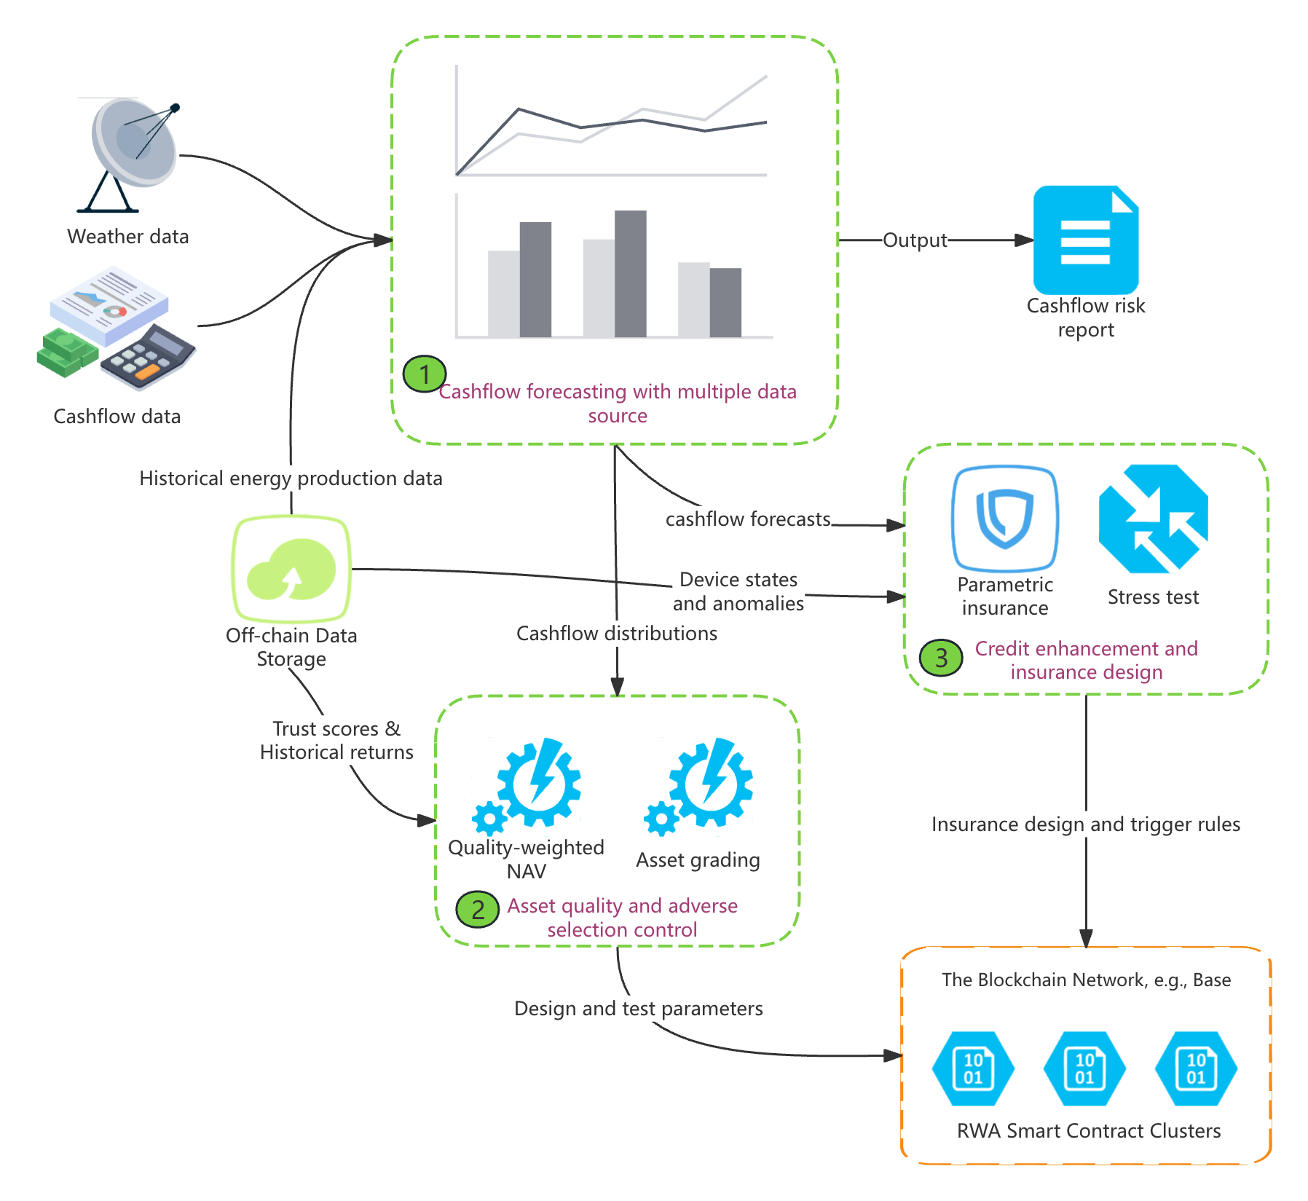
Energy RWAs are ultimately financed against future cashflows, and therefore the scalability of Deye’s RWA business line depends not only on credible data and automated settlement, but also on whether the project’s cashflows can be forecast, stress-tested, structured, and priced in a manner that meets the expectations of institutional capital. In practice, funders and sophisticated investors focus on downside protection and capital efficiency rather than average yield: they require quantified uncertainty around monthly revenue, transparent exposure to extreme scenarios (e.g., abnormal weather, curtailment, sustained downtime), and clear risk-mitigation mechanisms that prevent weaker assets from diluting stronger assets once they are pooled. The research agenda in this track addresses these financing frictions by developing a cashflow structuring and risk-pricing layer that connects oracle-attested production/settlement information to financeable product terms and on-chain implementation parameters (Figure 4). Concretely, the outputs of this layer include distributional cashflow forecasts and standardized risk reports, pooling and NAV rules that are robust to asset heterogeneity and adverse selection, and credit-enhancement/insurance trigger designs that reduce tail risk without requiring the issuer to provide discretionary guarantees. These outputs are directly actionable: they translate into vault admission rules, quality-weighted NAV computation, tranching design, reserve sizing, and verifiable trigger conditions that can be encoded into Deye’s RWA smart contract cluster.
Figure 4 Research direction: Cashflow Structuring and Risk Pricing
- ① Cashflow forecasting with multiple data source. How should multi-source information (i.e., historical production, weather/irradiance, settlement/tariff rules, and device-state signals) be combined to forecast cashflows as a full distribution rather than a single expected value? The intended deliverable is a periodic Cashflow Risk Report (VaR/CVaR-like measures and scenario outcomes) together with a scenario library capturing extreme but plausible conditions, providing funders with explicit downside metrics and supporting robust term-sheet design.
- ② Asset quality and adverse selection control. When heterogeneous inverter RWAs are deposited into a pooled vault, how can the system prevent “good assets” from being diluted by “bad assets,” which would otherwise deter high-quality contributors and destabilize pricing? The intended outputs include pooling mechanisms such as quality-weighted NAV, dynamic admission thresholds based on trust/return profiles, and optional segmentation/tranching, together with theoretical and simulation-based evaluation of welfare, discount ranges, and incentive compatibility under different asset-quality distributions.
- ③ Credit enhancement and insurance trigger design. How should tail risks (i.e., prolonged downtime, underproduction, settlement delays, or counterparty-related shortfalls) be mitigated through non-discretionary mechanisms such as parametric insurance, risk reserves, and formally verifiable trigger conditions? The intended outputs include trigger models and reserve-sizing recommendations supported by stress tests, targeting minimal capital occupancy for a desired protection level while ensuring that trigger events and payouts remain objectively auditable and enforceable within the RWA system.

3.3. Liquidity and Price Discovery in a Restricted (Compliant) Market
In the initial rollout of an energy-RWA product, secondary trading is typically constrained by regulation, licensing, and KYC/whitelisting requirements, even if the long-run objective is to support broader market access. These constraints materially shape market outcomes: restricting participation reduces the diversity of order flow and liquidity provision, which can widen effective spreads, increase slippage, and weaken price discovery, ultimately affecting investor confidence and the perceived “financeability” of the token. The research objective in this track is to treat AMM-based trading not as a generic DeFi primitive, but as a compliant market microstructure problem in which participation constraints, disclosure policies, and mint/redeem rules jointly determine liquidity quality and the stability of the market price relative to fundamentals. As illustrated in Figure 5, this research program interfaces with the RWA tokenomics smart contract cluster by producing implementable design parameters (fee tiers, incentive schedules, redemption windows/queues, and disclosure standards) and by quantifying performance impacts under realistic participant sets (institutional investors, whitelisted individual investors, and designated market makers) and regulatory constraints.
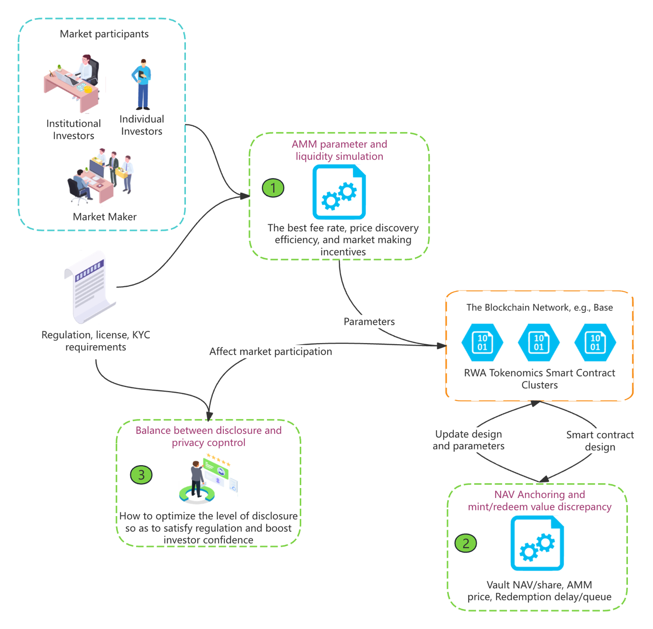
- ① AMM design under whitelist constraints. How should AMM fee tiers, curve selection, and market-making incentives be chosen when trading and liquidity provision are limited to KYC/whitelisted participants? The intended output is a calibrated simulation framework that quantifies liquidity loss under restricted participation and produces parameter recommendations that minimize slippage, effective spreads, and price impact for a given compliance perimeter.
Figure 5 Research direction: Liquidity and Price Discovery in a Restricted (Compliant) Market
- ② NAV anchoring and discount/premium control. How should mint/redeem access, redemption delays/queues, and dynamic fees be designed to keep the traded price of vRWA anchored to vault NAV per share, while remaining operationally compatible with RWA settlement frictions? The intended output is a set of anchoring mechanisms and policy rules that bound the distribution of discounts/premia across market conditions, together with stress-scenario evaluations that identify when and why persistent discounts may emerge.
- ③ Disclosure–privacy trade-off in compliant trading. What level of disclosure is sufficient to satisfy regulatory expectations and investor due diligence without unnecessarily exposing sensitive operational or commercial information, and how can selective disclosure be implemented in a verifiable manner? The intended output is a tiered disclosure standard (e.g., board/funder/regulator/public) supported by proof-backed summaries and auditable artifacts, with evaluation metrics that balance due-diligence coverage against information-leakage risk and its effect on market participation.

4. Research Timeline
Table 1. Research timeline with Deye RWA system milestone
Year | Deployment focus | System milestone | Research focus (what the lab delivers)
Y1 | Stage 1: Pilot (restricted investors) | Pilot architecture specification; telemetry ingestion, off-chain commitment, DON/router, on-chain record; reward funding/claim dry-run | Track 1 (Trust & Audit): baseline anomaly detection + trust score prototype; sampling baseline; state machine v1 mapped to payout holds/weights
Y2 | Stage 1: Pilot execution | Pilot live monitoring dashboards; monthly audit package; first external-style audit rehearsal; stable daily/periodic updates | Track 1 deepening: multi-source consistency (meter/weather/settlement); cost–risk curve for sampling; dispute/correction workflow; publishable empirical results on data integrity + audit economics
Y3 | Stage 2 prep: Vault/NAV design + restricted trading sandbox | Vault specification (vRWA NAV/share, mint/redeem policy, fee/reserve logic); restricted trading simulation environment (no public AMM yet) | Track 2 (Cashflow Structuring): distributional cashflow forecast + scenario library; pooling/adverse selection mechanism proposals; reserve sizing + parametric trigger candidates
Y4 | Stage 2: Controlled market launch | Compliant vault and (permissioned) AMM launch plan; NAV anchoring rules (queue/delay/dynamic fees); disclosure tiers; market monitoring KPIs | Track 3 (Restricted market microstructure): whitelist-constrained AMM parameter optimizer; NAV anchoring stability analysis; disclosure–privacy policy templates and proof-backed reporting; stress tests for discount/premium stability
Y5 | Stage 2: Scale + optimization | Parameter refinement loop (fee/incentives/redemption policy) based on observed KPIs; maturity playbook for replication across sites | Consolidated “design handbook” (1/2/3 outputs to implementable parameters); final academic outputs (papers, open-source tools if allowed); performance evaluation against KPIs (slippage/spread/discount stability/audit cost reduction)

Appendix A. Technical Details of the Design for the Main Workflow

A.1. Step ① inverter financing via RWA issuance and deployment.
A.1.1. Standard of token: ERC-3525 as default; ERC-1400 as compliant alternative.
Under the inverter scenario, the preferred token standard is ERC-3525 (semi-fungible token). ERC-3525 is selected because it natively supports the “one device, one on-chain identity” requirement: each tokenId can be bound to an inverter serial number (typically stored as a hash for privacy) and can carry device-specific metadata pointers (custody reference, valuation records, commissioning evidence). This structure enables per-inverter traceability across the asset lifecycle and provides a natural substrate for later asset management events (maintenance, replacement, retirement) without collapsing all devices into a single fungible pool. The primary trade-off is engineering overhead: ERC-3525 requires more custom integration work (wallet display, marketplace compatibility, indexing), and therefore increases audit scope relative to a simpler token.
A compliant fallback is ERC-1400 (security-token standard), which is appropriate when transfer restriction and administrative control are paramount. ERC-1400 provides standardized primitives for permissioned transfers (only KYC-approved addresses can hold/trade), global pause, and emergency compliance actions. The cost of this choice is functional and operational complexity: more intricate role management, higher audit burden, and reduced composability with open trading venues. For an RWA offering in Singapore targeting mixed investors, ERC-1400 may be required if the distribution channel or compliance partners insist on a security-token framework; otherwise, ERC-3525 with explicit transfer gating in the main contract often provides a more balanced implementation.
A.1.2. Contract design: DeyeRWA (token lifecycle & compliance) and RewardDistributor (USDC vault & claims).
The design should be explicitly separated into two contracts to reduce audit surface and to enforce a clean security boundary between (a) asset representation and (b) cash custody and payout execution.
DeyeRWA contract (ERC-3525 issuer and asset registry). DeyeRWA is the canonical on-chain record of “which tokens exist and what physical assets they represent.” It should implement ERC-3525 minting and maintain an internal “Asset Registry” keyed by tokenId. Each registry entry should minimally include: serialHash, siteHash, commissioningHash (pointer to the commissioning package stored off-chain), commissionedAt, and an explicit status field. The status should follow a strict state machine such as PENDING → ACTIVE → (SUSPENDED) → RETIRED, where (a) PENDING tokens may be minted during financing but are not eligible for rewards, (b) ACTIVE tokens are commissioned and reward-eligible, (c) SUSPENDED tokens are temporarily frozen due to disputes/faults, and (d) RETIRED tokens are permanently removed from reward eligibility (and optionally burned if the legal structure requires). Activation (PENDING → ACTIVE) should require multi-party authorization (e.g., issuer multisig plus custodian/installer attestation) to prevent over-issuance or “paper deployments.”
RewardDistributor contract (USDC custody and scalable reward claims).
RewardDistributor is the sole contract authorized to hold and disburse USDC rewards to token holders. It should not implement token issuance logic; rather, it should consume (1) the periodically reward amount determined by the oracle process and (2) an entitlement rule that determines who can claim. The contract should be designed to avoid on-chain iteration over holders, and therefore should implement a pull-based claim mechanism. The most scalable design for periodically payouts under a per-inverter token model is to store, for each day D, a distribution record containing: totalRewardUSDC, snapshotDefinition (or reference), and an entitlement commitment (typically a Merkle root over (claimerAddress, amount) for that day). Users then claim by submitting (amount, MerkleProof) and the contract enforces one-claim-per-day-per-address before transferring USDC.
A non-negotiable solvency constraint is that RewardDistributor must only “open” a day’s distribution if the USDC has actually been received on-chain. The recommended pattern is atomic funding: upon notifyReward(Date, amount), the contract executes USDC.transferFrom(treasury, address(this), amount) and reverts if the transfer fails. This ensures that any recorded periodically reward is fully funded, eliminating under-collateralized payout promises and strengthening auditability for investors and regulators.

A.1.3. Practical issuance and deployment workflow: mint/bind/activate aligned with financing milestones
Operationally, Step ① should be executed as a milestone-aligned lifecycle. Tokens may be minted during the fundraising phase (typically in PENDING status), but binding and activation must be conditioned on verified deployment. After funds are raised and procurement/installation occurs off-chain, each inverter’s commissioning package (serial, site, installer sign-off, gateway provisioning record, and optional meter installation record) is uploaded to off-chain storage; its hash is then anchored in the DeyeRWA registry, and the corresponding tokenId is transitioned to ACTIVE. Only ACTIVE tokenIds are included in subsequent daily reward entitlement computations used by RewardDistributor. This sequencing is critical: it prevents yield accrual to undeployed assets and provides a defensible on-chain audit trail that links investor funds to deployed equipment and to future cashflow eligibility.

A.2. Step ② Inverter data aggregation and oracle attestation (information stream).

A.2.1. Aggregation and output: “original data” and “hash commitment” as two parallel outputs
Inverter telemetry is first collected at scale (across many rooftops) and normalized by the Data Aggregator into a canonical periodic dataset. The aggregator outputs two artifacts in parallel. First, it outputs the original dataset (the full batch file containing inverter-level records for a given period), which is written to off-chain storage for durability, audit, and later dispute resolution. Second, it outputs a cryptographic commitment derived from that stored dataset—typically a batchHash (hash of the stored file bytes) and, when inclusion proofs are needed, a MerkleRoot over per-inverter records. The original dataset is required for transparency and third-party verification; the hash/merkle commitment is required for efficient on-chain anchoring and tamper detection. In practice, the oracle and downstream contracts rely on the commitment values, while the batch file serves as the immutable reference that can be re-downloaded and re-hashed to validate integrity.

A.2.2. Input data format and why DON consensus is important
The input to the oracle layer should be a deterministic “oracle package” produced per period, containing at minimum: {period_id, batchURI, batchHash, merkleRoot (optional), schemaVersion, timestamp} and, where appropriate, governance signatures (e.g., issuer/custodian) over these fields. The DON’s role is not to ingest raw high-frequency telemetry; it is to independently retrieve and validate the oracle package and (when configured) recompute the commitment from the referenced batch file to confirm that the published hash matches the stored data. DON consensus is important because it mitigates single-source failure and manipulation risks: a centralized publisher (or a compromised backend) could otherwise unilaterally post incorrect production numbers. By requiring multiple independent oracle nodes to converge on the same commitment values under a predefined verification procedure, the system strengthens data credibility for investors, auditors, and regulated distribution, and reduces governance disputes when rewards are computed from that data.

A.2.3. On-chain release via router contract and benefits over direct custom callbacks
Once the DON reaches agreement on the oracle package, it delivers the attested values on-chain through a router contract (FunctionsRouter smart contract). The router provides a standardized, access-controlled callback mechanism that routes the verified oracle output to the application layer (e.g., DeyeRWA and/or an oracle-commitment module), where the period’s batchHash/merkleRoot is persisted as the canonical on-chain reference. Using a router contract—rather than having your own contract directly accept arbitrary off-chain submissions—offers three practical benefits: (1) standardized security and authentication, since callbacks originate from a known router interface and can be restricted to verified request IDs and authorized oracle workflows; (2) operational robustness, because request execution, retries, and node coordination are handled within a mature oracle framework rather than bespoke infrastructure; and (3) clean separation of concerns, where your RWA contracts remain focused on asset lifecycle and payout eligibility while the oracle network and router handle off-chain retrieval and delivery. This reduces the audit surface of your core RWA contracts and lowers the risk that oracle-specific complexity compromises token logic or reward accounting.

A.3. Step ③ Cashflow settlement and on-chain reward funding (cashflow stream for rewards, parallel to Step ②).

A.3.1. How electricity is sold to purchasers
Electricity produced by the rooftop inverter fleet is monetized through one (or a combination) of standard sale channels, chosen according to the site’s grid interconnection and contractual environment. In the simplest structure, each rooftop site sells electricity under a power purchase agreement (PPA) to a building owner/tenant (behind-the-meter consumption), where revenue is calculated from metered consumption offsets at an agreed tariff. Alternatively, sites may export to the grid under an export arrangement where an offtaker/utility settles delivered energy based on revenue-grade metering at the point of common coupling. Regardless of channel, Step ③ should define a settlement basis that is objective and auditable—preferably a revenue-grade meter reading per site and period—because this becomes the authoritative reference for fiat revenue. Where multiple rooftops exist, revenue is naturally determined at the site level (metered settlement), and can later be allocated to individual inverter tokens using the production shares recorded in Step ②.

A.3.2. Fiat collection, stablecoin conversion, and funding the RewardDistributor contract
Once electricity is sold, the purchaser (utility/offtaker/building counterparty) pays Deye (or a dedicated SPV/treasury entity) in fiat, typically SGD, into a controlled bank account. Deye then converts the fiat proceeds into stablecoins (e.g., USDC) via a stablecoin issuer or regulated liquidity provider (or, operationally, via an exchange/OTC desk), and transfers the resulting stablecoins to the on-chain RewardDistributor contract on the target L2 (e.g., Base), as depicted in your workflow (bank → stablecoin issuer → stablecoins → RewardDistributor). For control and auditability, the recommended operational pattern is that the RewardDistributor opens a distribution period only when stablecoins are actually received on-chain: either the treasury directly transfers USDC into the contract, or the treasury grants an allowance and the contract pulls funds via transferFrom inside the same transaction that records the day’s funded amount. This ensures that any recorded reward distribution is fully collateralized by USDC already held in the contract, preventing “paper payouts” not backed by real cash receipts.

A.3.3. Ensuring consistency between Step ③ (cashflow) and Step ② (recording)
Consistency is achieved by a formal reconciliation policy that links the oracle-recorded production dataset to the cash settlement basis and enforces the link both operationally and on-chain. First, define the settlement truth as the metered energy and tariff terms used to compute fiat revenue (e.g., per-site export meter × tariff). Second, use Step ②’s inverter production records to provide an allocation basis (e.g., each inverter’s share of site production) while treating the settlement revenue as the binding total. Third, publish an auditable “daily settlement package” off-chain (meter readings, invoices, receipts, FX/stablecoin conversion details, and resulting USDC amount), store it in off-chain storage, and commit its hash alongside the day’s production commitment. Finally, enforce an on-chain solvency constraint in RewardDistributor: the daily funded amount must equal the stablecoins transferred in that day, and the on-chain record for that distribution must reference the corresponding Step ② commitment (period id / root / hash). Under this structure, Step ② determines what was produced and supports traceability, while Step ③ determines what was paid and guarantees that on-chain distributions never exceed realized and converted revenue. Any discrepancy (meter vs inverter sum, invoiced vs received, received vs funded) is surfaced as a flagged reconciliation state and can trigger a hold, correction, or audit workflow before claims are opened.

A.4. Step ④ On-chain accounting update and investor reward claiming (execution layer).

A.4.1. How the two contracts update records from the oracle contract
Upon DON consensus, the router contract delivers the period payload to the application layer. DeyeRWA records the canonical production commitment for the period—typically (periodId, batchURI, batchHash, productionRoot, status)—thereby anchoring the exact dataset from which rewards are computed. In parallel, RewardDistributor records the distribution commitment for the same period—typically (periodId, oracleRef, entitlementRoot, totalRewardUSDC)—where oracleRef explicitly references the corresponding DeyeRWA production commitment (e.g., by storing productionRoot or a commitment identifier). This dual-record design ensures that (a) the token contract remains the system-of-record for “what physical performance was attested,” and (b) the distributor contract becomes the system-of-record for “what payout entitlements are claimable,” with an explicit cryptographic linkage between the two.
Operationally, the update sequence should be deterministic and enforced by access control: only the router callback (or an oracle-authorized relayer) can write the period commitments, and the distributor should reject any distribution record whose oracleRef does not match a finalized production commitment in DeyeRWA. This prevents accidental or malicious creation of claimable entitlements not backed by the attested dataset.

A.4.2. Distribution contract design to prevent inconsistency between money and record
RewardDistributor must enforce a strict solvency invariant: a period becomes claimable only if the corresponding USDC is already escrowed inside the distributor contract. The preferred mechanism is atomic funding on record creation. Concretely, the function that opens a new distribution period (e.g., openPeriod(periodId, totalRewardUSDC, entitlementRoot, oracleRef)) must execute USDC.transferFrom(treasury, address(this), totalRewardUSDC) within the same transaction and revert if the transfer fails. As a result, the on-chain record of totalRewardUSDC cannot exist without the matching USDC being held by the contract, structurally preventing underfunded promises.
In addition, the distributor should enforce referential consistency by requiring that oracleRef corresponds to a finalized commitment in DeyeRWA, and should maintain one-claim-per-address-per-period bookkeeping to prevent double claims. If corrections are ever required (e.g., reconciliation dispute between Step ② and Step ③), the distributor should not overwrite existing state; instead, it should open a new versioned period record and explicitly invalidate the earlier one for claiming, preserving auditability and eliminating ambiguity about which entitlement set is authoritative.

A.4.3. Permit/approval model for claiming: treasury approval for USDC, eligibility anchored to the oracle commitment
Eligibility is proven cryptographically by presenting (amount, MerkleProof) against the stored entitlementRoot for the period. The only “permit” required for execution is therefore the treasury’s USDC allowance to the RewardDistributor contract (or a direct deposit), enabling the contract to pull and escrow funds atomically when opening each period. DeyeRWA’s role is to anchor the underlying production commitment and to ensure that only compliant/authorized oracle updates are accepted; RewardDistributor’s role is to enforce that payouts can only be claimed if they are (a) backed by escrowed USDC and (b) tied to a valid oracle-referenced entitlement root. This separation yields a clean security boundary: DeyeRWA governs asset identity and oracle record integrity, while RewardDistributor governs money custody and payout correctness at scale.

Appendix B. Technical Details of RWA Token Economics Design and Circulation

B.1. Step ① Institutional staking into the RWA Vault and liquidity seeding of the vRWA/USDC pool

B.1.1. RWA Vault contract: custody, share issuance, and reward capture
The RWA Vault contract is the canonical on-chain custodian of staked native RWA positions. Its primary function is to accept deposits of the issued RWA token from institutional investors and to mint vRWA shares against those deposits under a deterministic accounting rule. Because the native RWA token in your system is not a simple ERC-20 but an inverter-linked instrument (ERC-3525 preferred per your document), the Vault deposit interface must be defined in terms of token IDs and/or token “value” units, rather than “amounts” alone. Operationally, the deposit transaction transfers the relevant ERC-3525 positions from the institution to the Vault (making the Vault the on-chain holder for reward eligibility), records the deposited asset identifiers internally (so the Vault can later prove which underlying assets back outstanding shares), and mints vRWA to the depositor. For correctness and auditability, the Vault should maintain explicit mappings from deposited inverter token identifiers to Vault ownership state, and should enforce eligibility checks (e.g., only ACTIVE inverter tokens, not PENDING or SUSPENDED, can be staked), so that vRWA is never minted against undeployed or disputed assets.
A key design decision is how vRWA shares are priced at mint time. The formal objective is to keep vRWA as a share of the Vault’s net asset value (NAV): when a depositor contributes an underlying RWA position, they should receive vRWA proportional to the incremental NAV they contribute. In a pilot, NAV can be conservatively defined as “principal reference value per inverter” plus “USDC already accumulated in the Vault,” with the principal reference value taken from the offering terms (or a periodic on-chain reference set by governance). Under this rule, the Vault defines a share price $p_{t}=NAV_{t}/Supply{\left(vRWA\right)}_{t}$, and mints $ΔvRWA=ΔNAV/p_{t}$. This is the critical mechanism that makes vRWA economically meaningful and prevents dilution: early stakers cannot be unfairly diluted by later deposits if deposits are priced at the prevailing share price.
Once the Vault holds the native RWA positions, it should also be authorized to execute an auto reward claim against the existing RewardDistributor workflow (as indicated by the “Auto reward claim” arrow in your chart). Concretely, the Vault becomes the claimant/beneficiary for daily USDC rewards associated with the staked RWA positions, and periodically calls the RewardDistributor claim interface (either directly, or through a small “harvester” module) so that USDC is transferred into the Vault. Crucially, the Vault does not pay USDC out to vRWA holders in this step; instead, it retains the USDC as Vault assets. This retention is what causes vRWA to appreciate: as USDC accumulates, Vault NAV increases while vRWA supply remains unchanged, raising NAV per share. The Vault may also enforce a fee policy (management fee, O&M reserve, insurance reserve) by skimming a small portion of harvested rewards into a fee address or reserve bucket; for report clarity, this should be defined as a deterministic percentage and disclosed as part of token economics.
Finally, the Vault must define redemption semantics for vRWA holders, even if redemption is not the primary liquidity path. For a market-making design, redemption logic provides the economic anchor that keeps vRWA price linked to its underlying NAV. The cleanest and most operationally realistic redemption primitive is USDC-based redemption (burn vRWA for USDC subject to liquidity buffers or queue-based settlement) rather than “returning inverter token IDs,” which is difficult for retail and fragments the underlying. Even if you expect most users to exit via the AMM, specifying a redemption mechanism (even with delays) makes the system economically coherent and improves market pricing.

B.1.2. vRWA/USDC AMM pool: market access, price discovery, and liquidity provisioning
The vRWA/USDC pool is the primary market-making venue that converts the Vault share token into a retail-tradable instrument. Its function is to offer continuous exchange between USDC and vRWA: retail investors buy vRWA for USDC when seeking exposure to the yield-bearing RWA portfolio, and sell vRWA for USDC to exit without interacting with ERC-3525 tokens or reward claiming. This pool should be implemented as a standard AMM pair (e.g., Uniswap V3-style concentrated liquidity or a simpler constant-product AMM), with pool parameters chosen to reflect expected volatility and liquidity depth. For a pilot, a simpler constant-product pool can be sufficient; as volume grows, concentrated liquidity improves capital efficiency but increases operational complexity for liquidity managers.
Liquidity seeding is an explicit component of Step ①. Initial liquidity should typically be protocol-owned liquidity (POL) or institution-provided liquidity under a defined program. Practically, this requires both sides of the pair: the Vault (or treasury) must supply vRWA, and a treasury or designated liquidity provider must supply USDC. “Fee” from Vault to Pool can represent either (a) explicit incentives allocated to deepen liquidity, or (b) trading fees earned by LP positions that are owned/managed by the protocol. It is important to note that the AMM is not describing yield generation by itself; rather, it is an exchange venue whose price should track the Vault’s NAV-per-share, with deviations corrected through arbitrage and/or managed rebalancing.
The mint/redeem boundary is what prevents the AMM price from drifting without discipline, and therefore the Vault and pool must be designed consistently: if redemption is entirely impossible, vRWA becomes a pure “sentiment token” and the AMM price may decouple from fundamentals, which is undesirable for an RWA product.
A final design constraint is compliance alignment. If the underlying RWA exposure is KYC-gated (which is likely under your Singapore deployment), then the system must avoid inadvertently creating an unrestricted wrapper that circumvents transfer restrictions. In practice this means either: (a) vRWA itself is also transfer-restricted and the AMM pool is only accessible to whitelisted addresses, or (b) the wrapper and trading venue operate in a permissioned environment. This requirement affects the pool’s address eligibility, liquidity provider whitelisting, and the user onboarding flow for retail participants; it should be stated explicitly because it materially shapes market-making feasibility and liquidity depth.

B.2. Step ② Vault reward capture and “NAV → price” anchoring via arbitrage
Once the Vault holds the underlying ERC-3525 RWA positions, it is the party that is eligible to claim daily USDC rewards (either by calling the RewardDistributor directly or via an automated harvester). The Vault retains claimed USDC on its balance (net of predefined management/O&M reserves), so the vault’s net asset value increases over time. Because vRWA represents a pro-rata claim on vault assets, the fundamental value of vRWA is the NAV per share: as rewards accumulate, NAV rises while vRWA supply is unchanged, implying an increasing NAV/share (i.e., “yield by appreciation,” not by manual claiming for retail).
The AMM price of vRWA will fluctuate with liquidity and order flow. To keep the traded price aligned with NAV/share, the system should expose at least one economically meaningful “conversion boundary” between vRWA and vault value. The cleanest mechanism is a mint/redeem channel (even if redemption is queued rather than instant):
- If vRWA trades below NAV (discount), arbitragers buy vRWA cheaply in the AMM and redeem with the Vault for USDC at (or near) NAV/share, profiting from the spread and pushing the AMM price upward.
- If vRWA trades above NAV (premium), sophisticated participants create vRWA at the Vault’s current share price (by depositing eligible ERC-3525 RWAs, or by injecting USDC if you allow USDC-based minting) and sell vRWA into the AMM, increasing supply and compressing the premium.
In implementation, the Vault does not need to “actively manage price”; it needs to provide transparent NAV accounting and well-defined mint/redeem rules that make arbitrage feasible. The principal design choice is redemption design: (a) instant USDC redemption (requires a large USDC buffer), or (b) queued redemption (more realistic for RWA-backed principal). Queued redemption still supports price discipline, but the anchoring is weaker and discounts can persist during stress; this should be disclosed as a liquidity/risk feature rather than a bug.

B.3. Step ③ Retail trading through the vRWA/USDC pool and fee recycling to stakers
Retail users interact primarily with the vRWA/USDC AMM pool, purchasing vRWA using USDC and selling vRWA back to USDC to exit. This creates continuous market access without requiring retail users to hold or understand heterogeneous ERC-3525 tokenIds or to participate in reward claims. AMM swaps generate trading fees (in vRWA and/or USDC depending on the AMM design), which become a meaningful source of secondary yield if liquidity and volume are sufficient.
The LP position is owned by the protocol/Vault (POL), so trading fees accrue to the Vault and are retained. This increases NAV and therefore benefits all vRWA holders automatically through price appreciation.

